RC-Asia-China-Mirrors: Reflections of Eternity and Change

Contents
1.Mirror Symbolism: Philosophical Background
2. Warring states period 475-221 BCE

2. Pre-Han Mirrors
3. Han Period Mirrors
Western or Former (206 BCE — 9 CE)
Hsin or New Dynasty (9-25 A.D.)
Eastern or Later Han period (25 — 220 CE)
4. Tang Period Mirrors
Mirror Symbolism: the Philosophical Background
Mirror symbolism is mentioned in two Chinese classics the Zhuangzi and the Xun Zi. The Zhuangzi (莊子 , Chuang Tzŭ ), sometimes attributed to an author of the same name of the 4th century BCE Warring States Period, may have been written by a thinker of the third century CE named Kuo Hsiang. Xun Zi (荀子, Hsün Tzu) ca. 312–230 BCE was a pragmatic philospher of Qi (Shandong) who, counter to Mencius's view the innate goodness of humanity, countered that ethics was necessary to restore mankind's obscured sense of goodness.
In both of these classics the metaphor of the heart-mind (xīn jì, 心記 ) is referred to as a mirror. In the Zhuangzi, a heart-mind like a mirror constitutes the ideal state of unity with the Way: "The sage's heart-mind in stillness is the mirror of Heaven and earth, the glass of the ten thousand things." For Xun Zi, one must establish a heart-mind construct like a mirror in order to learn about the Way.
Originally, a bronze vessel filled with water was deemed "clear and pure enough to see your beard and eyebrows and to examine the lines on your face," so, too, can the heart-mind be clear and pure enough to respond appropriately to learning. In early Chinese bronze vessels used for this purpose the sentiment was inscribed in Oracle Bone Script on the bottom of the reflecting surface to promote one's daily self-introspection. The mirror metaphor was prominent in Chinese philosophy and was adopted by the Koreans, Manchurians and Japanese where (for the last) it is philosophically described in the Hotsuma Sutai.
Mirror Symbolism: Zhuangzi
Some of the earliest recorded references to bronze mirrors (jian) are found in the Zuozhuan (Commentary of Zuo). The Zhouli and the Huainanzi both refer to the use of bronze mirrors and concave mirrors (fu suior yang sui) in ceremonial practices. Mirrors came to be seen as active, responsive objects because they could be used to produce fire and water. When placed outside, concave mirrors focused sunlight to produce fire, while bronze mirrors gathered condensation in the light of the moon. But it was not simply the fact that mirrors had the power to gather or produce that made them objects of religious significance in ancient China; it was what they produced. Water and fire were thought to be the pure essences of yin and yang, respectively, and the fact that mirrors appeared to draw these substances from the sun and moon reinforced the cosmological power that was already associated with them. Mirrors were seen as responding to their environment by collecting water and fire, which is why, as Philip J. Ivanhoe has noted, mirrors came to be seen as offering "the paradigm for proper responsiveness: they reflect the true essence of the ultimate yin and yang—the alpha and omega of phenomena in early Chinese cosmology."
In his essay "A Metaphorical Analysis of the Concept of Mind in the Chuang Tzu," Harold Oshima writes that because the ancient Chinese saw mirrors as symbolizing a powerful connection to the powers of the heavens, mirrors "would have served admirably as a model for the xin ["heart-mind"]. To be sure, the mirror metaphor for the xin appears quite pedestrian and unexciting until we realize that the mirror itself was imagined to possess broad and mysterious powers." Oshima goes on to argue that the metaphor of the heart-mind as a mirror is the determinative model for a number of the Zhuangzi's ideas about the xin. The graph for xinis based on an oracle bone pictograph of the human heart, and it is used to refer both to the physical organ in one's chest and to the seat of such faculties as thinking, perceiving, feeling, desiring, and intending. The earliest known uses of the metaphor of the heart-mind as a mirror are found in the Zhuangzi. In chapter 5 Zhuangzi refers to "mirroring" (jian) as an activity: "Persons do not mirror themselves in running water—they mirror themselves in still water." In chapter 7 this activity is associated with perfected persons (zhiren): "Perfect Persons use their heart-minds like mirrors—going after nothing, welcoming nothing, responding but not storing." Later, this metaphor is used to describe the sage (shengren).
One of the first things to note about these passages is that the Zhuangzi uses the mirror metaphor at once to describe both stillness and activity. As the discussion preceding Zhuangzi's use of the metaphor in chapter 7 shows, the text describes certain kinds of activities or responses to the world and contrasts them with those activities that are not in accord with the Way:
Do not be an embodier of fame; do not be a storehouse of schemes; do not be an undertaker of projects; do not be a proprieter of wisdom. Embody to the fullest what has no end and wander where there is no trail. Hold on to all that you have received from Heaven but do not think that you have gotten anything. Be tenuous, that is all. Perfect Persons use their heart-minds like mirrors—going after nothing, welcoming nothing, responding but not storing. Therefore they can win out over things and not hurt themselves.
Perfected persons respond to the people or things that come before them, but the appropriate response does not include inciting, challenging, pursuing, or retaining things. This is why Zhuangzi says that perfected persons "go after nothing, welcome nothing" (bu jiang bu ying). Like mirrors, they do not pursue things, but they are responsive to things. Additionally, just as mirrors do not store or retain the images that pass before them, perfected persons do not retain or hold on to their previous activities or responses. They "respond without storing" (ying er bu cang), that is, they respond to each situation naturally, one at a time, without allowing the previous situation to interfere with the current one.
It is important to note that according to the mirror metaphor, it is the xin ("heart-mind") that responds in each situation. "Mirroring" is an ideal state in the Zhuangzi—the state that characterizes a sage. The xin is the appropriate way of describing the locus of this state because it is the seat of cognitive and affective capacities, as well as intentions and volitional powers. When perfected persons respond by moving in accord with the Way and in harmony with the cosmos, they do not passively reflect the Way. They illumine other things and respond with their cognitive, affective, intentional, and volitional powers all engaged properly. Here we should recall that for Zhuangzi none of these capacities is to be shut down or manipulated; rather, we must allow them to flow freely and spontaneously, unbound by the distinctions and categories that have been imposed on us by society:
Joy, anger, grief, delight, worry, regret, fickleness, inflexibility, modesty, willfulness, candor, insolence. . . . Let it be! Let it be! [It is enough that] morning and evening we have them, and they are the means by which we live. Without them we would not exist; without us they would have nothing to take hold of.
The ability to hold on to what one has received from Heaven and "respond without storing" constitutes a state of harmony with the Way. Here we can see how the Chinese understanding of mirrors as active, responsive objects informs the use of the metaphor in the Zhuangzi. Like mirrors, sages are the paradigm for proper responsiveness. When one's heart-mind is like a mirror, one spontaneously moves in harmony with the Way, "mirroring" Heaven and earth, and the ten thousand things.
In addition to responsiveness, mirrors carry the connotations of illumination in Chinese thought. The Zhuangzi tells us that the sage "illuminates (zhao) all in the light of Heaven. . . . So, I say, the best thing is to use clarity (ming)."The text uses a cluster of terms to describe the ideal state, many of which are also used to describe mirrors. The terms zhao ("illuminate," "reflect," "mirror") and ming ("bright," "clear") are two such examples, both carrying the sense of illumination. Mirrors in early China were thought to illumine or reveal objects that passed in front of them, just as sages were thought to have a profound effect on their surroundings. In chapter 5 the mirror metaphor is used to emphasize this effect. After noting that people mirror themselves in still water and not running water, Zhuangzi says, "Only what is still can still the stillness of other things" (wei zhi neng zhi zhong zhi). A mirror-like state of harmony with the Way allows sages to see things clearly and enables them to respond without prejudice or preference, but the proper response can only occur if the heart-mind is absolutely calm, like still water, which serves as a mirror.
In addition to the qualities of responsiveness and illumination, Zhuangzi also emphasizes stillness. The image of still water (zhi shui) serving as a mirror emphasizes the character of the sage's heart-mind, which is undisturbed by emotions or external influences. The text contrasts running or flowing water (liu shui) with water that stands still, perfectly flat and calm. In chapter 13 the text offers another description of stillness, again employing the metaphor of the heart-mind as a mirror:
Water that is still (jing) gives back a clear (ming) image of beard and eyebrows; reposing in the water level, it offers a measure to the great carpenter. And if water in stillness possesses such clarity, how much more must pure spirit (jing shen)? The sage's heart-mind in stillness is the mirror of Heaven and earth, the glass of the ten thousand things.
This passage places particular emphasis on the clarity of the images reflected in still water. Even the fine hairs of a person's beard and eyebrows can be viewed in such still water. This clarity serves as a metaphor for the clarity of the heart-mind, which, in its stillness (jing), is so clear (ming) that it is "the mirror of Heaven and earth, the glass of ten thousand things." Here we should recall that clarity is associated with mirrors, which "light up" or "illumine" what comes before them. The sage who mirrors Heaven, earth, and the ten thousand things sees them clearly, illuminated brightly. Here we see that in addition to the other uses we have noted, mirrors in early China were also sometimes seen as reflecting back the truth about the world accurately.
By referring to the ten thousand things, this last line shows the extent to which the mirror metaphor in the Zhuangzi is about more than the state of a person's heart-mind; it concerns the nature of the world and its relation to human beings. When one moves in accord with the Way, the need for a sense of self apart from the ten thousand things recedes, and one comes to see oneself as but a small part of the larger patterns and processes of the world. In this way, sages come to appreciate things as they really are, and rely on their spontaneous, pre-reflective intuitions for guidance. In chapter 13 the Zhuangzi calls this state "the perfection of dao and de" (dao de zhi zhi). Like a mirror, the heart-mind is responsive and illuminating, but it is also still and calm. Serving as the model of spontaneous movement and unity with the Way, the heart-mind is the model of proper responsiveness in the same way that mirrors are the paradigm of proper responsiveness when they produce water and fire, yin and yang.

Mirror Symbolism: Xun Zi
Although the Zhuangzi and the Xun Zi present opposing visions of human nature and self-cultivation, the Xun Zi is one of several texts that bear the mark of Zhuangzi's influence through the use of the mirror metaphor. In fact, Xun Zi's use of the metaphor bears striking resemblance to the passage we have examined from chapter 13 of the Zhuangzi. Both philosophers refer to the way in which still water can serve as a mirror, giving back a clear image of one's beard and eyebrows. But although this similarity might lead us to think that they use the mirror metaphor in the same way, Xun Zi transforms Zhuangzi's metaphor, using it to express and shape his own position. In chapter 21 Xun Zi prefaces his claim that the heart-mind is like a mirror with an important remark that serves as a guide to his use of the metaphor: "Only the junzi who has already become bright and clear (ming) is able to know the first hints of being anxiously on guard or of attentiveness to subtle manifestations." For Xun Zi, only those who have already become ming ("bright and clear") are able to come to know certain things about the Way. He goes on to say,
Hence, the human heart-mind may be compared to a pan of water. If you place the pan upright and do not stir the water up, the mud will sink to the bottom, and the water on top will be clear and pure (qing ming) enough to see your beard and eyebrows and to examine the lines on your face. But if a slight wind passes over its surface, the submerged mud will be stirred up from the bottom, and the clarity and purity of the water at the top will be disturbed so that it is impossible to obtain the correct impression of even the general outline of the face. Now, the heart-mind is just the same.
Although Xun Zi appeals to Zhuangzi's image of a person's beard and eyebrows, he develops the metaphor in a very different way. To begin with, Xun Zi describes a reflection in a pan of water, unlike Zhuangzi, who contrasts still water with flowing water, apparently in natural settings—rivers, streams, ponds, or lakes. In addition, Xun Zi introduces "muddiness" into the metaphor, focusing on the water's clarity or turbidity in addition to its stillness. For Xun Zi, an undisturbed pan of water must be both still and clear in order for one to see an accurate reflection of oneself. He writes that the heart-mind is just the same.
Thus, if you lead it with rational principles (li), nurture it with purity (qing), and not allow mere things to "tilt" it, then it will be adequate to determine right and wrong and to resolve any doubtful points. But if small things pull at it so that its right relation with the external world is altered and the mind's inner workings are "tilted," then it will be inadequate to decide even gross patterns.
Here again, we can see how Xun Zi develops the metaphor in a distinctive way. He is concerned with the pan of water being tilted, which would disturb one's ability to view an accurate, undistorted reflection. In addition to disturbing the water's stillness, Xun Zi tells us that tilting the pan makes the water murky, which also distorts a reflection. All of this, he maintains, resembles the task of the sage, who must not allow his heart-mind to be tilted or disturbed, and who must work to avoid stirring it up with distractions. For Xun Zi, the heart-mind's stillness and clarity is not a goal or end-in-itself, as it is for the Zhuangzian sage. Rather, a heart-mind that is bright and clear, like a mirror, is a necessary condition for learning about the Way. This aspect of Xun Zi's metaphor marks a contrast to Zhuangzi, for whom a heart-mind like a mirror constitutes a state of unity with the Way. For Xun Zi, the state of the water, like the state of the heart-mind, allows something else to be accomplished; the metaphor expresses an instrumental relationship. Just as a mirror is used for examining the whiskers and lines on one's face, a mind that is clear and free of distractions is used for learning about the Way. As Xun Zi develops the metaphor on his own terms, the differences from Zhuangzi's use of the metaphor become apparent. We find no traces of the still heart-mind as constitutive of the sage's harmony with the Way, evidenced by his spontaneous responsiveness to the world. For Xun Zi, a heart-mind like a mirror describes a state that is preparatory for learning about the Way.
It is worth noting that certain dimensions of Xun Zi's use of the mirror metaphor resonate strongly with his larger program of self-cultivation and the collection of metaphors he uses to describe it. The introduction of a pan of water as opposed to natural occurrences of water is consistent with Xun Zi's insistence that human nature is reformed from the outside in using the rites and traditions created by the sages over time. To illustrate and develop his view of the way human dispositions and attitudes are shaped, he often uses craft metaphors. Like the work of steaming and bending wood, or sharpening metal with a whetstone, water must be held still in a pan, where it is not at the mercy of the unpredictable forces of nature, such as wind and water currents. Rather, if someone holds the water perfectly still in a pan—a container that itself was fashioned by human hands—then it can be used as a mirror. Xun Zi's description of the mud, and the way it can be stirred up with even the slightest tilt, reinforces his insistence on the attentiveness and self-consciousness required of those who follow the Way. Here we see a contrast with Zhuangzi, who does not discuss the care one must take to avoid stirring up the mud at the bottom. Zhuangzi's metaphor does not even include a pan of water with mud at the bottom—only the contrast between flowing water and still water.
This difference points to another important contrast that we have already mentioned: Xun Zi seems to be more concerned with emphasizing clarity than Zhuangzi, who focuses more heavily on stillness. For Zhuangzi and the early Daoists more generally, getting in touch with one's spontaneous, pre-reflective intuitions means settling down and being at ease in the world. Zhuangzi's goal, then, is to make the heart-mind still. For Xun Zi, settling down in the Zhuangzian sense could only perpetuate the unrefined state into which we are born. Xun Zi thinks we need to work hard at being attentive in order to refine ourselves. The work that it takes to hold a pan of water perfectly straight without even the slightest tilt is another metaphor for his rigorous program of self-cultivation. Xun Zi's goal is to make the mind clear so that it is ready to learn.
Despite these differences from Zhuangzi, however, Xun Zi's use of the mirror metaphor is still distinctively Chinese. One of the clearest indications of this fact is Xun Zi's concern with the way that the heart-mind becomes preoccupied to the degree that it is unable to function properly in the moment: "if small things pull at it so that its right relation with the external world is altered and the mind's inner workings are 'tilted,' then it will be inadequate to decide even gross patterns." As we have already seen, one of the things that helped to make mirrors the paradigm of proper responsiveness in ancient China was the fact that they did not retain their previous images. As David Nivison has pointed out, Xun Zi is aware that the mind can become obsessed with the things it encounters, posing a danger that "can be met only by cultivating the mind's capacity to keep itself in order as it is functioning: to be open to new impressions no matter how 'full' it is, to keep its contents clear and distinct no matter how diverse they are, and to maintain a sense of reality no matter how free the constant movement of thought and imagination." Here we can see the resemblance between the heart-mind and mirrors, as Zhuangzi does when he discusses "responding without storing."
However, for Xun Zian sages, unlike Zhuangzian sages, the purpose of "mirroring" is to be receptive to learning about the Way. Nivison notes that Xun Zi sees the state of the heart-mind as "a means to clear thinking and correct judgment, not a religious goal, not an end in itself." Xun Zi's instrumental view of the heart-mind represents a marked contrast with the Zhuangzi, where a "heart-mind like a mirror" is a sagely achievement. For Zhuangzi this state is not a means to an end. But, Xun Zi tells us, "a muddied brightness (zhuo ming) casts an external shadow, and a pure brightness (qing ming) shows a reflection from within. The sage follows his desires and fulfills his emotions, but having regulated them, he accords with rational principles of order. . . . This is the way of putting the mind in order." The calm, clear, and bright heart-mind is a state that enables individuals to put their minds "in order" and learn about the Way, like the water's surface, which, when calm, clear, and bright, enables one accurately to view his beard, eyebrows, and the lines on his face.
Xun Zi says, "When water is moving and reflections waver, men do not use it to determine their beauty or ugliness." Likewise, if the heart-mind is not still, one cannot use it to learn about the Way. Although Xun Zi does not take the state of the "heart-mind like a mirror" to be an end in itself, he still maintains with Zhuangzi that it is responsive, as mirrors are responsive, and also that mirrors sometimes function to tell us the truth about the world. However, although the heart-mind is clear and calm like a reflective surface, it is not confined to passive reflection. It also responds actively, lighting up the things that pass before it.
Mirror Symbolism: The Parasol
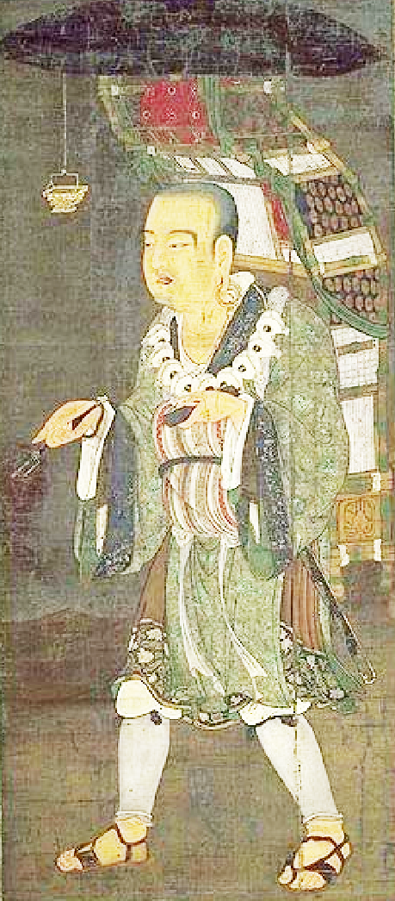
Parasols or canopies made of feathers, straw plait and wood were used in rites and ceremonies and were depicted in the art of Han, Six Dynasties, Tang as dangling from a curved stick for individuals or suspended from ceilings, in temple courtyards before the Hall of the Buddha. Their composition ranged from feather cloth and textiles to plaited straw and wood. The centre of the mirror corresponds to the pivot of the umbrella and forms the highest point of the whole construction. The main decorated zone of the mirror is its convex obverse (above). The depiction of the parasol of Xuan Zang (玄奘 , Hsuan-tsang, b. 602 CE) in the famous portrait commemorating his traverse of the Silk Road into the vast regions of Xinjiang and India beginning in 629 CE) is a good example where the decoration on its convex top shows clusters of grapes which had a prominent place in the development of Tang Period Five Lion Dance Mirrors which will be discussed below.
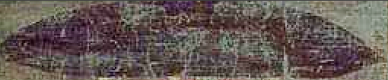
Xuangzang, silk screen portrait, Tokyo National Museum based on the stele in the Xian Belin Museum with detail of parasol.
Xuangzang, Xian silk screen portrait, Tokyo National Museum
Spring and Autum Period Mirrors
Warring States Period Mirrors
The Warring States Period (戰國時代; Zhànguó Shídài), 475 BCE to the unification under the Qin Dynasty in 221 BCE. as the second part of the Eastern Zhou Dynasty, following the Spring and Autumn Period, although the Zhou Dynasty ended in 256 BCE, 35 years earlier than the end of the Warring States period. The beginning of the Warring States Period is disputed: 403 BCE, the date of the tripartite Partition of Jin, is also considered as the beginning of the period.
an era when regional warlords annexed smaller states around them and consolidated their power. an era when regional warlords annexed smaller states around them and consolidated their power, schools of thought include those of Mencius, Sun Tzu, Lao Zi, Zhuang Zi, Han Feizi, Xun Zi and Mozi.
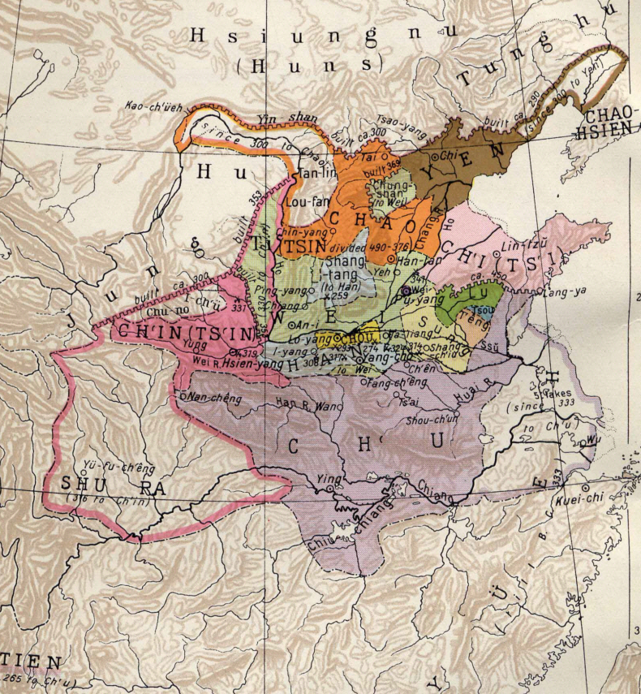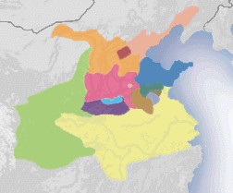
The state of Wei(魏) (in magenta) should not be confused with the smaller state of Wei(衛) (in pink).
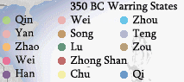
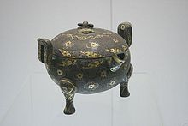
A Warring States bronze ding vessel with gold and silver inlay

Pre-Han Mirrors

These mirrors are without inscriptions and have geometric motifs on the obverse suggestive of the theme of eternity and change.

Han Period Mirrors
The Han period may be divided into three sub-periods, the Western or Former (206 BCE — 9 CE), the reign of Wang Mang, the so-called Hsin or New Dynasty (9-25 A.D.) and the Eastern or Later Han period (25 — 220 CE). Inscriptions assist in distinguishing pre-Han mirrors from those of the Han period, because they are all written in the small seal script of the Ch'in, the arch enemies of the pre-Han Ch'u, and for this reason the script was not adopted before 213 BCE
Western or Former (206 BCE — 9 CE); Shou-chou Dragon Mirrors
Shou-chou was given to a type of Former Han mirror that was discovered near Shou-chou in the Huai river valley, a town that became the capital of Ch'u in 241BCE and remained prominent until the death of prince of Huai-nan, Liu An in 122 BCE, after which the bronze smelters were abandoned and with them the production of the Shou-chou mirrors.
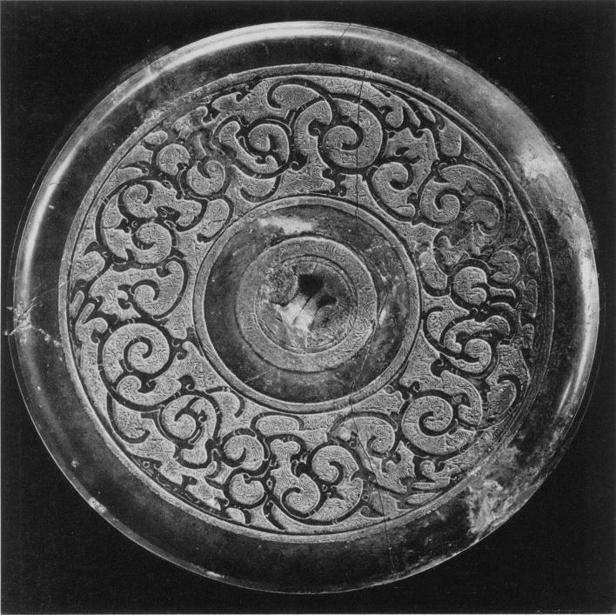
Fig. 1, Shou-chou, Type 1, mirror
Diam: I 4. 3 cm
By courtesy of His Majesty, the King of Sweden, Huai and Han, Cat. E pl. 2.
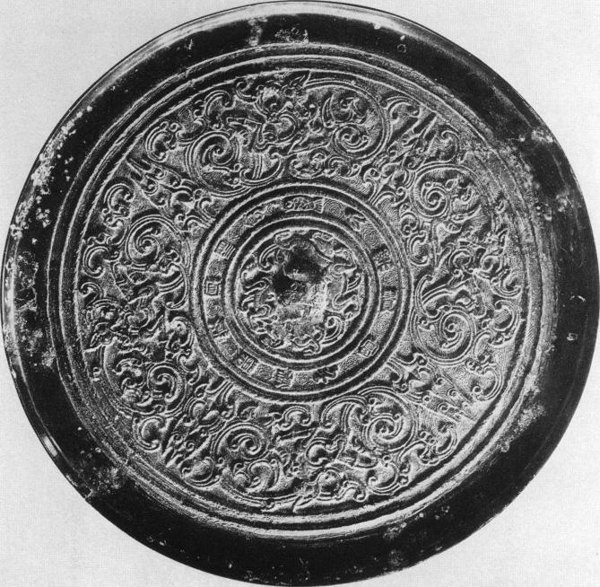
Fig. 2, Shou-chou, Type 2, mirror
Diam: I 8 cm
By courtesy of His Majesty, the King of Sweden, Huai and Han, Cat. F pl. 8.
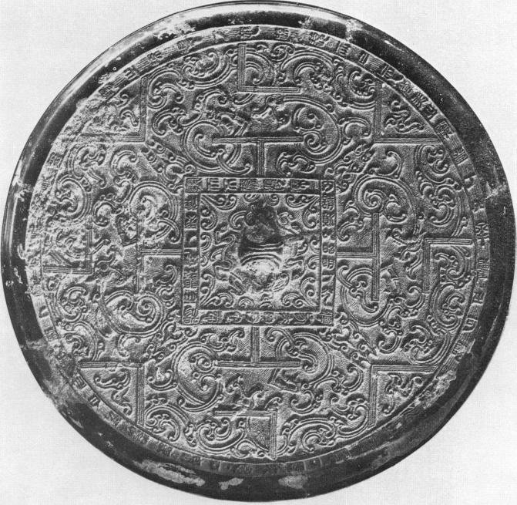
Fig. 3, Shou-chou, Type 3, mirror
Diam: I 9 cm
By courtesy of His Majesty, the King of Sweden,
Shou-chou mirrors decorated with winding arabesques are often called p'an ch'ih, (winding dragon) mirrors (ch'ib is sometimes interpreted as being a young dragon without horns). Type 1 Shou-chou mirrors of the second part of the third century have small fluted central bosses and concave rims with pronounced outer edges. Type 2 Shou-chou mirrors of the second century have. a plain ring or rope pattern encircling the cental zone, which may enclose a crouching animal-shaped knob.
Western or Former (206 BCE — 9 CE): TLV Mirrors
Type 3 Shou-chou mirrors of the later second century have a square central field with a border that may encompass an inscription. The "T " motif is found on the central square with L's and V's on the circular outer rim. This so-called "TLV" design had its origin in the cosmological Liu-Po game involving the tension between eternity and mutability. Han stone tomb-chamber bas-reliefs, notably those in of Wu Liang's family in Shantung, depict players on opposite sides of a board emblazoned with the" TLV" motif. UMEHARA Sueji in his Selected Ancient Mirrors Found at Shaohing Tombs shows four immortals playing at a board which closely resembles that on the Han bas-reliefs with the TLV motif. The mirror bears the inscription "immortals playing the game liu-po (),
The game liu-po is cited in the third century BCE poem, Chao hun , by SUNG Yu describing liu-po as one of the enjoyments of this world in order to entice a certain to return to thoughts of this earthly paradise and forsake his concentration on the heavenly one:
With bamboo sticks and ivory draughtsmen,
There is the game liu-po.
Dividing into groups and proceeding together,
Forcefully they threaten each other.
Having become hsiao (i. e., in the lead) and going
to win double,
One shouts for the five-white . . . (Yang 1947:204)

This sentiment appears to mirror the tension between the contesting philosophies of Zhuangzi and Xun Zi, the former opting for concentrating on eternity the latter on this world. The game is mentioned also in the first half of the second century by Wang I so that these two references anchor the game to the Han period. It appears to have had two methods of play, one by six long sticks (chu) as in the mirror (Fig. 5) and the other by the throw of six small bamboo dice, both kinds of draughts being called chu (Yang 1947:204). The use of the long sticks recalls the practice of divination where long sticks are shaken out of an open-ended hand-held box.

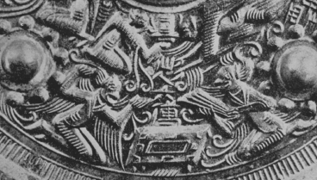
Fig. 5, Mirror depicting ”immortals playing the game of Liu-po" Asano Collection, Osaka

Western or Former (zo6 BCE — 9 CE): Mountain Cloud (Shan) Mirrors
Perhaps one of the most provocative of these geometric abstractions used in Han mirrors was the Shan symbol for mountain embedded within a cloud-like pattern, signifying the eternality of the mountains that supported the dome of heaven. In these provocative mirror designs one can witness the evolution of the Chinese bronze craftsman's ability to impose the Shan symbol within a matrix of cloud motifs. The number of Shan symbols could vary from three to six, not necessarily depending on the size of the obverse field, but they all performed the same purpose of maintaining the dome of heaven and the sense of Shang-ti, the immutable order of the universe. Within the perimeter of the mountains clouds endlessly float, signifying the mutability of the world through which they passed. This duality of permanence and mutability on reflecting surface displays the mutability of the mirror's owner.

Tang Dynasty Mirrors
The casting of bronze mirrors with elaborate decoration on the reverse can be traced back in Chinese history to the beginning of the Bronze Age. Not only were such mirrors used in daily life, they were also considered sacred objects. Many scholarly studies on the decor of mirrors of the Han dynasty (206 BC—AD 220) have addressed the symbolic portrayal of the universe and the forces within it. By the Tang dynasty (618-907), however, the happiness of this world as well as glorification of the ideal world appear in mirror decoration. The celestial context of the ornamentation gradually gave way to the idealization of a blissful land. Undoubtedly, the Tang people regarded bronze mirrors as durable
precious treasures. Materials such as gold, silver, and mother-of-pearl were expressively applied, with imaginative birds and flowers, fantastic animals, and grapevines floating exuberantly across these sumptuous surfaces.
In major museum collections around the world, Tang mirrors of exquisite quality often stand out from other bronze decorative art. Furthermore, Tang mirrors survive in noticeably larger quantities than earlier bronze mirrors, which suggests a growing presence at that time of socially and economically prominent gentry and merchants. Wealthy cosmopolitan patrons living in this prosperous and stable time created a market of sumptuous artistic connoisseurship that reached its peak around the late seventh to the beginning of the eighth century. As Professor Juhsi Chou has pointed out, the dynastic capitals, or at times secondary capitals, tended to be centers for the production and consumption
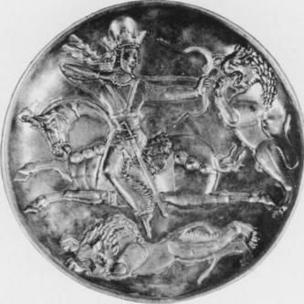
Fig. 1. Plate with Embossed Figure of Shapur II Hunting Lions, Sassanian, 4th century, partially gilded silver, Diam. 22.9 cm.The State Hermitage Museum, St. Petersburg. After Ryoichi Hayashi, The Silk Road and the Shoso-in, trans. Robert Ricketts (New York:Weatherhill, 1975), pl. 140.
of mirrors. By the Tang dynasty, in addition to the capitals,Yangzhou produced exquisite mirrors and sent the best ones to the imperial court as tribute.
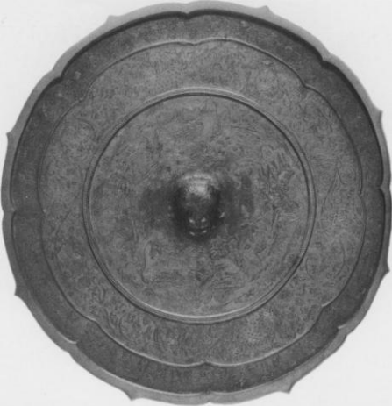 Fig. 2. Octafoil Bracket-lobed Mirror with Landscape [picturing the realm of immortals] and the Eight Divinatory Trigrams, silvered bronze, Diam. 40.7 cm. Shoso-in, Nara. After Nihon bijutsu zenslal (Tokyo: Gakusha Kenkyajo, 1978), 5: 53.

The opening of China's frontiers and the influx of Buddhist culture brought with it new inspiration for the vocabulary of decorative art. Many novel and exotic foreign objects were imported along the silk routes. At the same time, the Chinese worked on their own innovative ideas to fulfill their sense of creativity. The imperial house patronized skilled metalsmiths and cultivated the taste for refined details, luxuriant designs, and inlays such as lacquer, glass, gold, and silver. The refined techniques developed in gold and silver ware, such as the Sassanian silver plate with partially gilded embossed figures (fig. 1), provided critical inspiration for the production of Tang mirrors.

The cosmopolitan culture of Tang China not only reflected intensive interests in western counterparts, but also exerted a strong impact on Korea and Japan in the east. In fact, many superb Tang mirrors among those best known today are in the Shoso-in repository of the Todai-ji monastery at Nara in Japan. This legendary collection of imported Tang decorative art was primarily inherited from Emperor Shomu (r. 724-749 CE).The emperor, a devoted Buddhist, made the initial dedication of precious religious implements to the eye-opening ceremony of the bronze Great Buddha of the Todai-ji in 752. After Shomu died in 756, his widow, the dowager empress Komyo, dedicated to the Buddha more than one thousand items from the late emperor's favorite personal and household belongings in five installments!' Included in this mid eighth-century repository are many Tang artworks ranking from fairly high to the very best quality, even by Chinese standards.
The legacy of the Shoso-in collection provides us profound examples for the technical excellence and exquisite design ofTang decorative art. The large quantity of mirrors (more than fifty) in the collection demonstrates that bronze mirrors were indeed highly appreciated by the court. Notable in this context is the eight-lobed mirror with silver back depicting the realm of the immortals (fig. 2).
Tang mirrors preserve the world of artistic imagination as well as the cultural memory of the people at the time. To understand fully the iconology of the decorative motifs on these mirrors, one has to look further into decorative arts such as textiles, gold and silver, pottery, and architectural decoration. In general, however, unlike the abstract cosmological patterns of the Han TLV mirrors, those of the Tang era focus more closely on the living world of birds and flowers, animated animals, and idealized immortals living in a scenic garden.
Floral Motifs
Floral motifs are probably the most common decoration on Tang mirrors. In addition to depictions of peony, camellia, and gardenia on the backs, the contours of many mirrors are themselves designed to imitate that of a full-blown flower with six or more petals. A splendid example is an eight-lobed mirror with floral motif in the Sumitomo collection of the Senoku Hakko Kan (fig. 3). In the outer circle, an array of eight large floral patterns fills up the entire space with a sense of voluptuous elegance. A mirror of similar design is in the Carter collection (fig. 4); both are in the style of the eighth century.
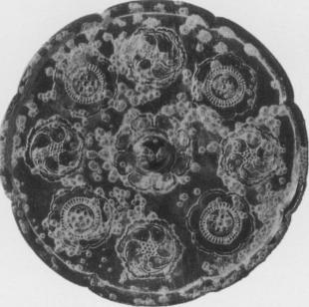
Fig. 3. Eight-lobed Mirror with Eight Blossoms, 8th century. Sumitomo collection, Sen-oku Hakko Kan, Kyoto. After Higuchi Takayasu, Kyookan (Kyoto: Senoku Hakko Kan, 199o), pl. 87.
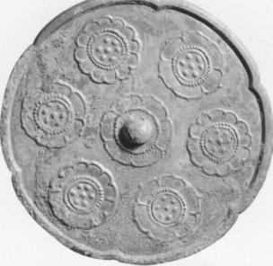
Fig. 4. Lobed Mirror with Six Blossoms, 8th century, Diam. 19.1 cm. The Cleveland Museum of Art, Gift of Drs. Thomas and Martha Carter in Honor of Sherman E. Lee, 1995.36o.
In fact, variations of lobed and foliated mirrors became the favorite contours of the Tang craftsman. The popularity of flower motifs, especially that of the lotus flower, has always been associated with the demands of Buddhism. For example, a brilliantly painted and gilded wood object in the form of a lotus (fig. 5) presumably served as a base for an offering lamp used in a temple. The icon of a fully blossoming lotus flower is also a prominent decorative element in Buddhist architecture in the Yungang cave temples during the Northern Wei dynasty around the 460's. Moreover, from early Buddhism on, lotus flowers were widely applied to halos, for instance, to symbolize the brightness of Buddha's wisdom. However, we should not overlook the fact that as early as the Han dynasty, the lotus flower was often painted on the ceiling of a tomb chamber to symbolize the celestial body. Therefore, the widely applied lotus flower on mirrors seems to be a happy combination of ancient symbolic association and newly popularized Buddhism.
Besides the lotus flower, floral motifs on Tang mirrors were often inspired by sophisticated designs on textiles imported from the Near East through the Silk Road. With great enthusiasm, Tang emperors demanded that scholars in the court prepare meticulous records and studies of the exotic plants, animals, and artifacts brought by foreign envoys.⁹ Such records provided a wide-ranging array of innovative ideas to the delight of the aristocratic society in the capital.

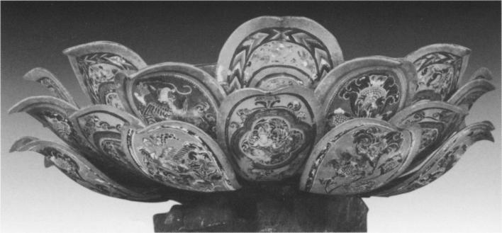
Fig. 5. Lotus-flower-shaped Pedestal, lacquer and gold-leaf on wood, H. 17 cm. Shoso-in, Nara. After Nihon bijutsu zenshtl, 5: 94, 95.
The roundel pattern in the center of the Shoso-in mirror with mother-of-pearl inlay (fig. 6) is as splendid as that of a multicolored rug. Four smaller roundels appear equally spaced in the outer circle. Set against a black lacquer background, mother-of-pearl as well as amber, tortoise shell, and rock crystal are employed to compose a fantastic design. The iridescent brilliance of the mother-of-pearl and the bright colors of the stones achieve a glittering effect on the surface, at the same time suggesting volume and mass in their curvilinear forms.
Another powerful example of floral motifs is seen on the gold and glass-backed cloisonné mirror (fig. 7). Of shiny silver on the front, on the back are three overlapping layers of six-lobed lotus-flower patterns in gold and cloisonné enamels.The striking lotus petals are covered with patterns and stripes in relief in green, black, and brown, imitating the taste of Birds and Flowers.
Bird-and-flower motifs, especially that of a bird holding a flowering branch in its beak, are considered auspicious signs in Chinese tradition. Floral patterns and blossoms take on an almost metaphysical quality in the lively design of an eight-lobed mirror backed with gold and silver in the Cleveland Museum of Art collection and a square one with a similar.three-color pottery popular at the time. The distinct sculptural quality sets it apart from other Tang mirrors, and it is unique in every aspect of design, material, and technique.
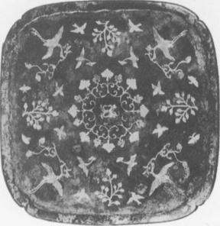
Fig. 9. Mirror with Pingtuo (Heidatsu) Decoration, 8th century, H. 14.9 cm. Asia Society; New York, Mr. and Mrs. John D. Rockefeller III Collection of Asian Art, 1979.119.

design in the Asia Society collection in New York (figs. 8, 9).A special technique of decoration, called pingtuo in Chinese or heidatsu in Japanese, is applied to this type of mirror. Delicate designs of birds, flowers cut
in gold, and silver leaves are embedded in a lacquered surface. Against the black-lacquer background, the thin strips of gold and silver decor display a distinctive high luster. Although different in shape, these two
mirrors follow the same symmetrical design order and can be dated to the beginning of the eighth century.
One of the strengths of the Tang mirrors in the Carter collection falls in the category of simple yet elegant bird-and-flower mirrors (fig. 10). An interesting comparison is offered by a piece in the National Palace Museum,Taipei (fig. 11). Serenity permeates the compositions of these two eight-lobed mirrors.A pair of ducks or phoenixes in flight, symbolizing auspiciousness and happiness in marriage, makes mirrors of this kind precious presents for weddings and other occasions. In addition, the brilliant rosette pattern on the top of the mirror in the National Palace Museum and the symmetrical branches of flowers on the Carter mirror each display a sense of harmony and prosperity appropriate for good wishes. Plants and Animals
Undoubtedly, animal-and-grapevine mirrors are the most famous Tang mirrors. Such mirrors are well documented and make up the largest group from the tombs dated between 664 and 711.¹⁰ Grapes were introduced into China from the west as early as the Han dynasty." Animal-and-grapevine mirrors characterize best the sculptural quality and compelling energy of the Tang culture in the latter half of the seventh
to the beginning of the eighth century. The decorations on two mirrors in the Carter collection (figs. 12, 13) demonstrate the excellence of the type.The more sophisticated one (fig. 13) displays a delight of energy and abundance. Heavy grapevines and grapes float into the background like a melody eulogizing the world of bird and animal. In the center field, playing in the midst of grapevines, six lion-like creatures, including the one crouching in the middle, each look in various directions in metaphysical poses. In the outer field, birds either spread their wings or stand still vigilantly. Realistic details of the animals, such as their fur and spines, are carefully described to attract the attention of the viewer.
Simple but vigorous designs of bird and animal are set against a clear background in the bracket-shaped mirror in the collection of the Arthur M. Sackler Museum, Harvard University. In the large center field, amid scrolls of fully blossoming flowers, two fantastic animals and two phoenixes occupy the four directions. The joyfully strutting lions each raise one paw and hold a flowering branch in another paw while looking at phoenixes perching in the back. In the narrow outer field, peaceful garden scenes with birds and flowers are depicted. Mirrors of this type have been found in tombs datable to the period from 690 to 710.
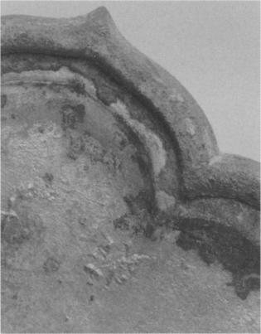
Fig. 14b. Detail showing inscribed date under the inset plaque [note: the
inscription was incised in the mold and appears backwards on the mirror]. Arthur M. Sackler Museum, Harvard University Art Museums, Bequest of Grenville L. Winthrop, _{1943.52.168.} Photograph courtesy Arthur M. Sackler Museum, Harvard University.
Fig. I4a. Mirror with Foliate Rim and with Inset Silver Plaque, dated 693, cast bronze with inset silver repousse plaque, Diam. 15.8 cm. Arthur M. Sackler Museum, Harvard University Art Museums, Bequest of Grenville L. Winthrop, 1943.52.168. Photograph courtesy Arthur M. Sackler Museum, Harvard University. | 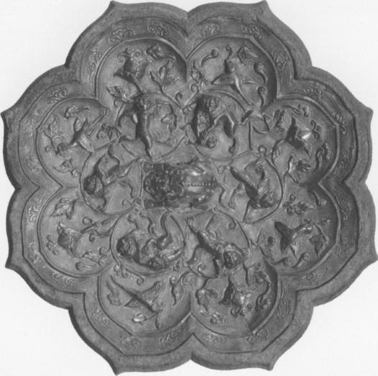

A related bronze mirror, also at the Sackler museum (fig. i4a), provides additional documentation. An inscription incised under the silver backing of the mirror bears the date of 693 (fig. 14b).'' The knob at the center assumes a crouching zoomorphic form, from which radiate six circles. Inside each circle a striding animal reaches out to touch its enclosing vine scroll with its paws.The outer circle of the mirror is decorated with eight brackets, each depicting either a branch of a flower or a bird.

The dragon mirror. Closely identified with Chinese culture and commonly employed as a decorative motif in every artistic medium since the Shang dynasty (ca. 1600—1100 BCE), dragon mirrors became popular in the eighth century. One dragon mirror presents a full moon in the shape of a dragon. The dragon's head and neck twist up to the right, legs up in the air and wide-open mouth touching the knob of the mirror. Small puffs of cloud emerge from the feet and float into the sky. The curvilinear movement of the composition and powerful modeling of the dragon in this type of mirror demonstrate well the compelling forces of the universe.
Landscape and Human Figures
Human figures appear in Tang mirrors first as part of hunting scenes, a motif popular in the mural painting of the imperial tombs dating from the late seventh to the beginning of the eighth century. The theme of hunting for pleasure took another ancient and metaphysical form as the search for immortality; as early as the Warring States period (481-221 Bc), in many tombs the soul of the deceased riding on a dragon on the way to immortality was depicted." Two splendid examples are in the Sumitomo and the Carter collections (figs. 15, 16).The simplified rocks with vegetation on the Carter mirror indicate the land of the immortals; on the Tokyo mirror, a cloud leads each dragon or phoenix to the ideal world.
Fig. 15. Eight-lobed Mirror with Four Immortals, 8th century. Sumitomo collection, Sen-oku Hakko-kan. After Higuchi Takayasu, Kyookan, pl. 97. | 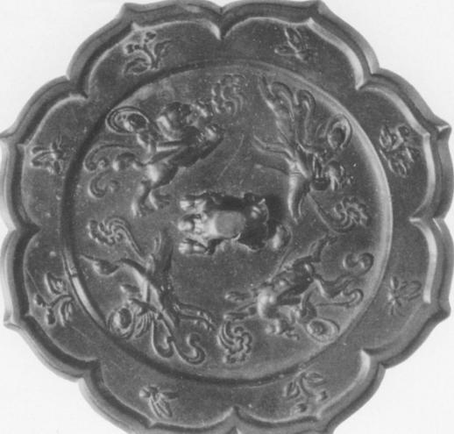

Fig. 16. Octafoil Mirror with Hunters and Prey, late 7th—early 8th century, Diam. 19.9 cm. The Cleveland Museum of Art, Gift of Drs. Thomas and Martha Carter in Honor of Sherman E. Lee, 1995.365. | 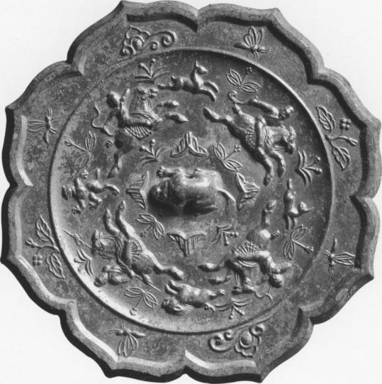

The most elaborate depiction of the Taoist realm of the immortals is the large silver-backed mirror in the Shoso-in (fig. 2). Encircling
the outer frame of the mirror, full-fledged geese, ducks, peacocks, and phoenixes perch on large flower heads attached to long baroque scrolls. The landscape depicting an auspicious land of happiness in the large inner circle is a new motif of Tang mirrors. Like pivots of the four quarters, mountains rise above the ocean in the center. In the intermediate spaces appears either a flying dragon or a gentleman playing music accompanied by a dancing crane. This delightful and detailed composition must have derived from the emergence of the mature landscape painting style in the eighth century.
By the mid eighth century, the human figure appears in the landscape, relaxing in a confined corner of a private garden. A lobed mirror with a tortoise knob, musician, and phoenix (see p. 56, fig. 12) is a good example. In front of the bamboo grove, a musician or immortal sits down to play for the dancing phoenix. In between, a lotus pond is decorated with rocks. A mirror with a comparable motif was excavated
from a tomb in Luoyang dating to 784:⁴ The back of this mirror is inlaid with mother-of-pearl in a bold pictorial rendition of a joyful garden party (see p. 36, fig. II). At either side of a blossoming tree sits a gentleman entertained by wine and music. The rest of the space is filled with an attendant, a few birds, rocks, and wine vessels. The soft and voluminous rendering of the motif characterizes that of the Tianbao era (742-755) or even later.
The elaborate ornament of meticulously depicted flowers and animals in these mirrors celebrates the good wishes and prosperity enjoyed by the Tang people. Concern with naturalism and a search for ideal beauty compete with each other within the design. The cosmopolitan culture in the capital opened up a new range of imagination and expression for
the artists and artisans. The mature style of Tang art captures the enduring energy of the universe in microcosm.

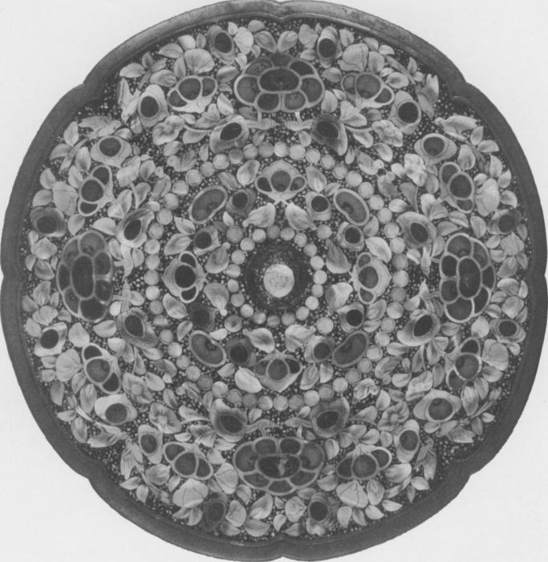
Fig. 6. Mirror, mother-of-pearl inlay, Diam. 27.2 cm. Shoso-in, Nara. After Nihon bijutsu zenshu, 5: 49.

- 9Emperor Taizong, for instance, ordered just such a careful official record in
647. See Tang hui yao [Tang dynasty encyclopedia] (Taipei: Shi jie shu ju, 1960), 100: 1796.
- 10At least fifteen animal-and-grape mirrors have been discovered in dated tombs; the earliest one is dated 664; see Wenwu, no. 7 (¹972), 33⁻4¹. For the list of dated tombs with animal-and-grapevine mirrors, see Yen, "Tangdai tongjing," 335.
- 11Schuyler Cammann, "The Lion and Grape Patterns on Chinese Bronze Mirrors," Artibus Asiae 16 (1953), 265-91.
12.The inscription was first published by Umehara Sueharu, Toky5Taikan [Conspectus ofTang mirrors] (Kyoto: Dohosha, 1984, reprint of 1945 edition), pl. 99b and pp. I00-I01.
- Sofukawa Hiroshi, "Kandai gazoseki niokeru shosenzu no keifu" [The lineage of ascending immortals in the pictorial stone of the Han dynasty], Toho Gakuho 65 (1993), 23-221.
Wenwu, no. 5 (1956), 41

(Kirkland, Russell. Taoism: The Enduring Tradition. Routledge: New York, 2004. Pgs: 33-34; Fung, Yu-lan (translator). (1933). Chuang-tzǔ: a new selected translation with an exposition of the philosophy of Kuo Hsiang. Shanghai: The Commercial Press. Reprint: 1964. A Taoist Classic: Chuang-Tzu. Beijing: Foreign Languages Press.)
Translation adapted from Burton Watson, The Complete Works of Chuang Tzu (New York: Columbia University Press, 1968), p. 142 (chap. 13).
Translation adapted from John Knoblock, Xun Zi: A Translation and Study of the Complete Works, vol. 3 (Stanford: Stanford University Press, 1994), p. 107 (Xun Zi 21.7b).
For helpful studies of the mirror metaphor in Chinese thought, see Paul Demieville, "The Mirror of the Mind," trans. Neal Donner, in Peter N. Gregory, ed., Sudden and Gradual: Approaches to Enlightenment in Chinese Thought (Honolulu: University of Hawai'i Press, 1987), pp. 13–40 (originally published as "Le Miroir Spirituel," Sinologica 1 [2] [1947]: 112–137); Harold H. Oshima, "A Metaphorical Analysis of the Concept of Mind in Chuang-Tzu," in Victor H. Mair, ed., Experimental Essays on Chuang-tzu (Honolulu: University of Hawai'i Press, 1983), pp. 63–84; Julius Tsai, "The Mirror Metaphor in the Zhuangzi," unpublished ms., presented at the Annual Conference of the Society for Asian and Comparative Philosophy, Honolulu, January 1998. Karen L. Carr and Philip J. Ivanhoe also make a series of important remarks about the mirror metaphor in their The Sense of Antirationalism: The Religious Thought of Zhuangzi and Kierkegaard (New York: Seven Bridges Press, 2000), pp. 38–39, 56, 71.
For an overview of these and other uses and understandings of mirrors in ancient China, see Joseph Needham, Science and Civilisation in China, vol. 4, part 1 (Cambridge: Cambridge University Press, 1962), pp. 87–94.
Carr and Ivanhoe, The Sense of Antirationalism, p. 38.
Oshima, "A Metaphorical Analysis of the Concept of Mind in Chuang-Tzu," p. 75. With the exception of terms appearing in titles, for consistency I have converted all Wade-Giles romanizations to pinyin in this essay.
Adapted from Watson, Chuang Tzu, p. 69 (chap. 5).
Ibid., p. 97 (chap. 7).
Ibid., p. 142 (chap. 13).
Adapted from ibid., p. 97 (chap. 7).
Ibid., p. 38 (chap. 2).
Ibid., p. 40 (chap. 2).
As Julius Tsai has pointed out, mirrors were thought to "provide better and truer insight into the nature of things, people, and spirits, revealing what was hidden to the naked eye" (Tsai, "The Mirror Metaphor in the Zhuangzi," p. 5).
Adapted from Watson, Chuang Tzu, p. 69 (chap. 5).
Ibid. The idea that virtuous individuals have de, a kind of moral charisma that attracts others and has a settling effect on them, seems to be implied in this passage. For a helpful study of this concept, see Philip J. Ivanhoe, "The Concept of de ('Virtue') in the Laozi," in Religious and Philosophical Aspects of the Laozi, ed. Philip J. Ivanhoe and Mark Csikszentmihalyi (Albany: State University of New York Press, 1999), pp. 239–257.Watson, Chuang Tzu, p. 69.
Adapted from Watson, Chuang Tzu, p. 142 (chap. 13).
Philip J. Ivanhoe has coined the phrase "pre-reflective intuitions" to refer to the innate tendencies that are already moving us toward the proper ends in life for Zhuangzi. A. C. Graham has also discussed the significance of pre-reflective tendencies in Zhuangzi's thought. See Carr and Ivanhoe, The Sense of Antirationalism, pp. 33–42, and Graham, "Taoist Spontaneity and the Dichotomy of 'Is' and 'Ought,"' in Mair, Experimental Essays on Chuang-tzu, pp. 3–23.
It is also possible that Zhuangzi and Xun Zi are drawing on a common literature, which is lost to us, but because of the similarity in imagery and what we know of the history of these texts, it is at least plausible to infer a direct borrowing. However, nothing in my analysis depends on this being true. In addition to Xun Zi, Chinese Buddhists also picked up the mirror metaphor and developed it in a distinctive way. In turn, the Neo-Confucians adapted the metaphor from the Chinese Buddhist usage. For a helpful study of the interaction between the Buddhist and Confucian traditions in China, see Philip J. Ivanhoe, Ethics in the Confucian Tradition: The Thought of Mengzi and Wang Yangming, 2nd ed. (Indianapolis: Hackett, 2002).
Adapted from Knoblock, Xun Zi, 3 : 107 (Xun Zi 21.7a);
Knoblock, Xun Zi, 3 : 107
Knoblock, Xun Zi, 3 : 107
T. C. Kline III has made the helpful distinction between "outside-in" approaches to self-cultivation, such as Xun Zi's, where one's behavior is reformed from the outside through the use of traditions and teachers, which eventually work to transform one's internal feelings, inclinations, and attitudes, and "inside-out" approaches, such as Mengzi's, which argue that one must begin by appealing to certain internal feelings as a way of reforming one's behavior. See T. C. Kline III, "Moral Agency and Motivation in the Xun Zi," in T. C. Kline III and Philip J. Ivanhoe, eds., Virtue, Nature, and Moral Agency in the Xun Zi (Indianapolis: Hackett, 2000), pp. 155–175.
For example, Xun Zi writes: "A piece of wood straight as a plumb line can, by steaming, be made pliable enough to bend into the shape of a wheel rim, so its curvature will conform to the compass. Yet, even though it is then allowed to dry out completely in the sun, it will not return to its former straightness because the process of steaming has effected this change in it. So, too, wood that has been marked out with the plumb line will be straight and metal that has been put to the whetstone will be sharp. In broadening his learning, the junzi each day examines himself so that his awareness will be discerning and his actions without excess." (Adapted from Knoblock, Xun Zi, 1 : 135 [Xun Zi 1.1])
Knoblock, Xun Zi, 3 : 107 (Xun Zi 21.7b).
David S. Nivison, "Xun Zi and Zhuangzi," in Kline and Ivanhoe, Virtue, Nature, and Moral Agency in the Xun Zi, p. 181.
Ibid.
Knoblock, Xun Zi, 3 : 108 (Xun Zi 21.7d).
Ibid., p. 109 (Xun Zi 21.8).
UMEHARA Sueji, (Kyoto, 1939), plate 6.
YANG Lien-sheng, "A Note on The So-called TLV Mirrors and The Game Liu-po," Harvard Journal of Asiatic Studies, Vol. 9, No. 3/4 (Feb., 1947), pp. 202-206
Chuan-yingYen, "Tangdai tongjing wenshi zhi neirong yu fengge" [Decorative patterns on Tang bronze mirrors], Bulletin of the Institute of History and Philology, Academia Sinica, 60, part 2 (1989), 289-353.
Kong Xiangxing, "Sui tang tongjing de leixing yu fenqi" [Typology and periodization of Sui and Tang mirrors], in Zhongguo kaogu xuehui di yi ci nianhui lunwenji (Beijing:Wenwu, 1980), 380-99.
Ju-hsi Chou, Circles of Reflection: The Carter Collection of Chinese Bronze Mirrors (Cleveland: Cleveland Museum of Art, 2000), 7.
One of the earliestYangzhou mirrors was produced in mid autumn of 622 and inscribed as a tribute to the court on the first day of 623. Wang Fu, Chongxiu Xuanhe bogutu (c. 117o-80) [Revised illustrated antiques of the Xuanhe era (c. 1170-80)], reprint of 1603 edition (Taipei: Xinxing, 1969), 29: 16.
Jessica Rawson, "The Ornament on Chinese Silver in the Tang dynasty (AD 618-906)," British Museum Occasional Paper, no. 40 (London: British Museum, 1982), 1
Hayashi Minao, "Chilgoku kodai ni okeru renge no shocho" [The symbol of the lotus flower in ancient China], T5h5 Gakuho 59 (1987), 1-61.

